Platform, 2020, Martin Lerma
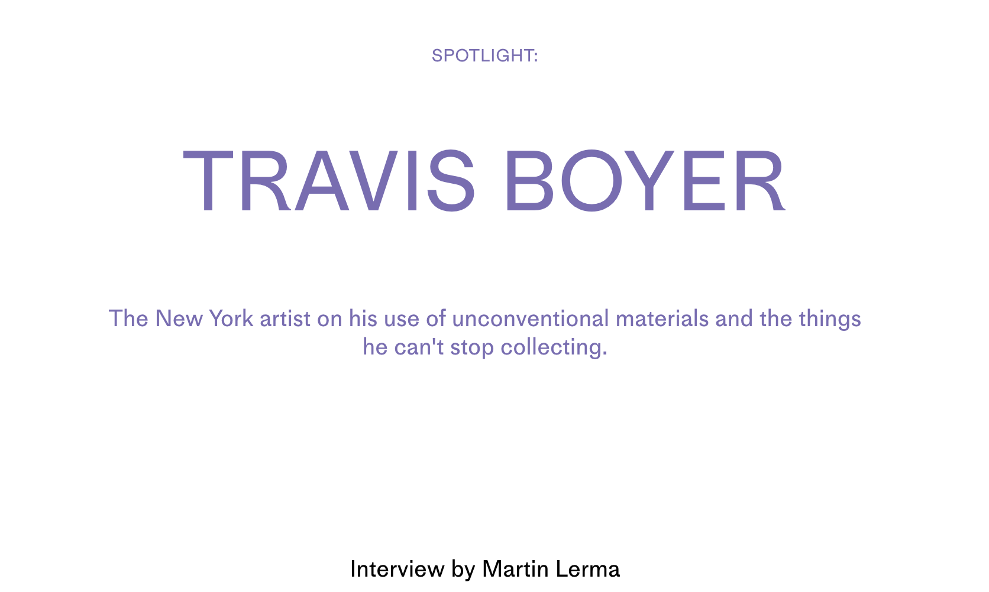

Travis Boyer avoids obvious choices. Where most painters embrace paint and traditional canvases, Boyer opts for velvet and special dyes. The same goes for the many idiosyncratic collections the self-professed 'feelings hoarder' has curated over time. Boyer spoke with Platform about how the late singer, Selena, impacted him growing up in Texas, why he loves old VHS documentaries, and what he prefers about listening to music on the radio versus Spotify.

Platform
You're really drawn to using a lot of different textures and materials in your work. Why do you tend to use them in your practice as opposed to other more “traditional” materials?

Travis
When I was growing up, I learned from a family friend about weaving, silk painting and things like that. When I went to college and learned more about oil painting and other traditional approaches, I still had this kit of materials of silk fabrics and dyes. I just always thought “Oh, that thing still looks way better.” The end result to me just seems more appealing. Something that I felt my painting peers saw as an alternative process was more primary for me in terms of an approach to making something beautiful. I've always also just been drawn to silk, silk-velvet, natural dyes, beeswax, things that come from a different kind of alchemy in terms of art making. There's also something very bodily about them, about their behavior, especially the velvet. It’s a really old material that goes back to the middle ages, but whether it's interpreted as being fancy or cheap or trendy or expensive, there's just something kind of sensual and strange about it.

Platform
What made you start painting on those surfaces? Did that require learning a whole new skill set?

Travis
I've been doing it since I was really young. So new skill set? No. Did it involve really expanding and being dedicated to that skill set? Yes. It’s something that's a little bit connected to watercolor, but what is unique about it is understanding the surface tension because it's like stain painting. The surface drinks the dye and you're trying to see how well you can control how far it's going to spread and whether the color starts to break up. Is it going to deposit a very thin darker line at the point that it starts drying up? Do you need to have a hairdryer standing by as you're doing it? When you're doing anything with dye, it's kind of a “no-whammies” approach. Once you've decided to apply color or go with something, you can't really dial it back like with regular painting. To access a complicated analogy, have you ever seen this movie Roman Holiday with Audrey Hepburn and Gregory Peck?

Platform
Yeah, of course!

Travis
There's this moment in Roman Holiday – it's a black and white movie where she's this runaway Princess slumming it – she goes to the barber and the barber is sort of resistant but agrees to cut all her hair off. There's this brief psychological moment where she's like “What have I done?” and the barber’s like “What have I done?” Then he turns her cheek and sees that it wasn't such a bad move and that he can figure out how to transform her into this chic, androgynous gamine. And I'm like, that's actually what success looks and feels like in my painting practice. It's no-whammies, just this big haircut where you’re like, “Oh shit, what have I done?” and then, “Oh, that's actually really nuanced and beautiful.”

artist Travis Boyer studio
Platform
Is that about embracing chance, accidents, things like that?

Travis
Yes, and then if I don't like it immediately, I rip it off the canvas and it goes into a different category of art. There is another waste stream that creates beautiful art as well.

Platform
You spoke a little bit about Roman Holiday and movies. What other media do you find particularly inspiring?

Travis
I mean this is just an honest answer but I know how interesting it is: In my studio practice, for a long time I've had this white VHS/TV combo, and I really like all of these PBS and Canadian Film Board documentaries about artists. There's a beauty to the film. They've been filming a still of a great painting, like a Georgia O'Keeffe painting, then there's the film-to-video transfer, then there's this kind of strange VHS image of what is a still painting. And this was how a lot of really critical culture was brought into people’s homes before the internet. But to me, it has a very calming look and vibe, and I think sometimes when I'm thinking about color relationships or this kind of softness, I do think about the way these beautiful paintings looked on a VHS tape.

Platform
I love that. Are those types of documentaries an example of something you collect?

Travis
Oh, yes. Among other things; I'm a self-described feelings hoarder. VHS documentary about roses from the early ‘90s, that's just on.

Platform
What are some of the other things you collect?

Travis
I don't want to create unnecessary competition out there in the world for the things that I'm tracking on eBay, so I will answer this question as best I can. Something I'm really interested in collecting is Peruvian three-dimensional weaving that comes from Ayacucho from the ‘80s. There were primarily two families that did it, one of which was the Sulka family. I have probably 10 or 12 of their weavings. You can see them as rugs or tapestries or however you want to see them, but they depict ancient Peruvian fabrics in motion. There's all this light and shadow and 3D effects that are programmed into the finished product. There might be an image of an ancient textile waving inside of a contemporary textile. They were made during this period of time in the ‘80s where there was essentially a civil war going on in Peru and these weavers in Ayacucho were caught in the middle. Because they were indigenous, they were suspected of being part of this Maoist communist rebellion, but because they were capitalists with the means of production to sell their wares, they were also threatened by the rebels who saw them as potentially part of the problem. So, they brought their weaving practice into the home, where it was safe. Somehow, out of this space of really high anxiety, this really beautiful and unique type of weaving emerges.

Platform
To backtrack for a second, you referred to yourself as a 'feelings hoarder.' What do you mean by that?

Travis
There are a lot of things that I collect instinctually. I have a big collection of clothing that Selena designed over the last two years of her life. When I had the opportunity to do it, I had a strong instinct that someone needed to collect these feelings. It's like an aspect of that history both for this famous celebrity who died tragically, but also for people in Texas who grew up adjacent to that culture and deep in that culture. I guess it's a kind of fan-ship for certain types of material culture. Also, jokingly, my husband calls me a scatter hoarder. It's not like you come into my house then there are stacks of newspapers or anything like that. But I do sometimes just ensure that something's going to be OK, whether I've stored it in your garage, or left it in the town where I found it at a friend’s house or borrowed the storage from the framer or whatever. I don't necessarily keep all these things at my fingertips.

Platform
Did you start your Selena collection because you, like her, are also from Texas?

Travis
Yeah, I'm from Texas. Her death was a very profound thing to happen when you're a teenager. I think that it's such a big subject that there's a lot of people with a different kind of adjacency to that story. Those are stories that need to be explored and told, but for my part, what I mostly have thought a lot about or focused on are the things that she made for us. The music part and her image gets repackaged and sold every so often, but the fact that she was making this clothing line that sort of looks like Eckhaus Latta and it's completely divorced from her stage image, that was sort of the thing that I wanted to make sure made it past eBay and garage sales and things like that.

Platform
Since we're talking about a musician: is music something that you like to listen to while you're working?

Travis
This is a space that's really changing. I listen to a lot of NTS radio. I think it stands for Nuts to Soup, but it's a UK-based internet radio station. In terms of feeling nostalgic or accessing these other periods of time in your life through music, that can be a kind of a hindrance, or it can be confusing. I think that the way we consume music evolved a lot. I drive a 2003 Honda Element that's full of CDs. Obviously, the CDs started to peter out around 2006 as a format. Driving in my car is a certain kind of musical time capsule. But then I feel like all of these things – like trying to listen to music through Spotify or your own iTunes collection – what I don't like about it is that there's a lack of privacy. You feel like, “Oh, the music's actually listening to me. It's collecting data about me, it's trying to guess, it’s trying to guess again because I didn't like that.” In a way, it’s stressful. I really like listening to NTS radio now. I barely know who the DJ is, and it moves in and out of music that’s recognizable and not, but to me, it feels much more like the open road. You’re not having to make these consumer choices about how you want to frame the freaking moment. It’s actually kind of a relief.

Platform
If you weren't an artist, what career do you think you would pursue?

Travis
I don't often not do something just because I'm an artist. Obviously, this was a complicated year, a complicated 18 months, and I didn't just retreat into my practice. I did a lot of going to other states and registering voters. I also helped out with a palliative care non-profit. I definitely have those instincts of self-deployment when things get difficult. There's not a topic or career zone that I am somehow not accessing or sacrificing by being an artist instead. I will say that I look forward to the kinds of other work that I'm going to get to do when I'm really freaking old. I think I'm going to be really funny and good at it. I would love to be the guy who gives the historical home tours and tells you gossipy things about, you know, Monsieur and Madame who built the house and the great expense they went to. Or even maybe passing out programs at the Met Opera.

There's something vocational about my vibe and the way I look, and I think a level of openness that I put out there. I already feel like I work everywhere. If I'm in a store, people will be like, “Oh, can I get this in a medium?” One thing about New York right now, we have these cool shacks for the restaurants, but it means that you're often walking down the sidewalk in between the storefront restaurant and the shack. It doesn't matter if I have a coffee in my hand, people will be like, “Can I get a napkin?” Or, “Can you check on my order?”

Platform
Those initiatives that you mentioned, like registering voters and the palliative care organization, what draws you specifically to those kinds of things?

Travis
Urgency. I'm the type of person who can only read about a problem for so long before I'm like, “Well, OK, guess I'm buying a ticket to go to Mississippi,” or, “Guess it looks like some people are going to need to be trained in this”, or, “This PPE needs to be moved from here to there.”

Platform
Have you gone down any Internet rabbit holes lately?

Travis
I really like to look at weird beach towels on eBay and Etsy. It’s incredibly nuanced. Obviously, there are some showstopper beach towels out in the world that kind of anyone would love to own, but searching “vintage beach towel lot” or “beach towel logo” is incredible. Old beach towels that say things that are directly ironic like, “Prozac beach towel.” That was a pharmaceutical giveaway. Or there's a green Lehman Brothers beach towel, and you're like, “That would be funny on the beach.” But then there are other ones that are more nuanced. You know Cathy, the cartoon?

Platform
Yeah.

Travis
There’s a Cathy one where Cathy's laying on the beach towel and it says something like, “I love this because it's the only time my stomach looks flat.” I just thought the towel was so complicated because you're weirdly now the same scale as Cathy and you are sometimes thinking about how your stomach looks when you're laying on a beach towel but then Cathy's the one in the room who can say it.

Platform
Is there anything you wish you were asked more often?

Travis
That's a complicated question. I try to interpret that question as: are there things I say to myself I wish you had asked me? Or I wish you had consulted me on? I know a lot about cars, I can sit and talk about cars for a really long time. I have a pretty good ear for them, like being in a car and saying, “I think this is the problem.” A lot of New Yorkers bought used cars recently, and I wish many of my friends had just forwarded me the listing and asked me what I thought. Then they wouldn’t have gotten a lemon. I do wish people would ask me about car stuff more before they get too invested or it's too late or they end up with a cracked head gasket and I'm like, “Well, I could have told you.” I do feel like, as New Yorkers, sometimes we just assume that we would know how to deal with that, and then your life isn't set up for it the same way as people who live in other parts of the country. You're just kind of suddenly overwhelmed by the responsibilities that came with your new Subaru Legacy.

Platform
I love it. I think that's the perfect place to end unless you had anything you wanted to add.

Travis
No, I think that's good. It's a real butchy note to end on. So, I talked about Roman Holiday and Selena, but I’m also into cars.

Platform
Listen, some of my favorite things, so that's all good with me.

